Brussels 13 November 2020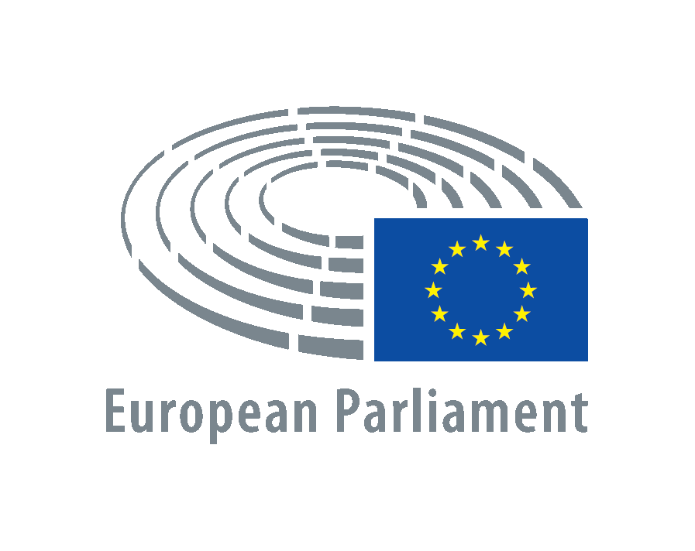

**Miguel Urbán Crespo**

European Parliament

Bât. Willy Brandt

60, rue Wiertz / Wiertzstraat 60

B-1047 Bruxelles/Brussel

[miguel.urbancrespo@ep.europa.eu](mailto:miguel.urbancrespo@ep.europa.eu)

**On the situation on the Guerguerat and the Western Sahara**

To the attention of High Representative of the Union for Foreign Affairs and Security Policy Mr Josep Borrell Fontelles,

The Guerguerat, the area located on the southern limit of the Western Sahara territory, between the Moroccan wall and the border with Mauritania, is a buffer zone according to the 1991 peace agreements and military agreement number 1. Therefore, it is an area under MINURSO control, not allowing none of the two parts involved to make use of it. However, despite the provisions of the peace agreement, three years ago Morocco began to pave a road in this area.

The clear intention of the construction of this road is to use the Mauritanian border to take out all kinds of goods and resources from the illegally occupied territory of Western Sahara. From drugs (see the various confiscations made in the area by the Saharawi army, always with MINURSO as a witness) to goods that are the result of the illegal resources plundering. Goods and resources that belong to the Saharawi people. That is to say, goods and resources that are doubly illegal, first because they are plundered materials and secondly because they are taken out from that area, whose use is prohibited to the parts.

Already in 2016, in light of the passivity, if not connivance, of MINURSO in relation to these works, the Saharawi army had to occupy the area as a protest to the UN for abandoning its obligations regarding the peace agreement, once again. However, that incident, which was close to restarting hostilities, did not put an end to either Moroccan colonisation cravings or the passivity of MINURSO. What is more, in recent years the paving of the road has been completed and MINURSO has done nothing to control these illegal flows.

Faced with the ongoing inaction by the UN, the Saharawi army once again occupied the Guerguerat. In response, the Kingdom of Morocco accuses the Polisario of failing to comply with the peace agreements. Agreements that have been breached, precisely, by the Alawite kingdom: with the illegal occupation of the territory, the blocking of the referendum, the human rights violations against the Saharawi population and the plundering of natural resources (prohibited to the occupying powers according to international law).

For this reason, in the face of the systematic breach of the peace plan by Morocco, and in the face of silence and inaction by the UN and the international community, the Saharawi civilian population has taken the reins of the situation in that area, that belongs to their territory. This is the result of a terrible frustration feeling from Saharawi people after almost 30 years of the presence of MINURSO, without seeing any results. And within the framework of these civil and peaceful protests by the Saharawi people, it is essential that the UN moves away from Moroccan incitements that seek to demonize these protests. It would be scandalous if the Sahrawi population, dispossessed of everything, could not exercise their legitimate right to peaceful protest, either.

Saharawi people are tired of both unfulfilled promises and inaction from the international community. Faced with the failure of the UN to seek the solution to which treaties and international legislation oblige, the Saharawi people have made the decision to act in the Guerguerat. Decolonizing the Sahara and ensuring the right of self-determination for the Saharawi people cannot wait any longer.

Therefore, the signatory MEPs ask you to use your powers to ensure that:

1. the European Union condemns the Moroccan military action against the Saharawi population in an area under the control of MINURSO
2. the European Union mediates to make sure that Morocco immediately closes the illegal breach it opened in its military wall in the Guerguerat area, since this is a persistent violation of both the military agreement n. 1 and the spirit of the peace plan.
3. the European Union takes practical and serious measures for MINURSO to carry out the primary mandate for which it was created, that is, the holding of a free and fair referendum in which the people of Western Sahara exercise in a free and democratic way their inalienable right to self-determination and independence, thus bringing to fruition the decolonization of the last colony in Africa.

In addition to these requests, the signatory MEPs show our support for the peaceful protest of the Saharawi civil society and reaffirm our commitment, as public representatives, to reach a democratic solution for the aspirations of the Saharawi people. A solution that requires the exercise of the free right to self-determination.

Sincerely,

Miguel Urbán Crespo, MEP GUE/NGL