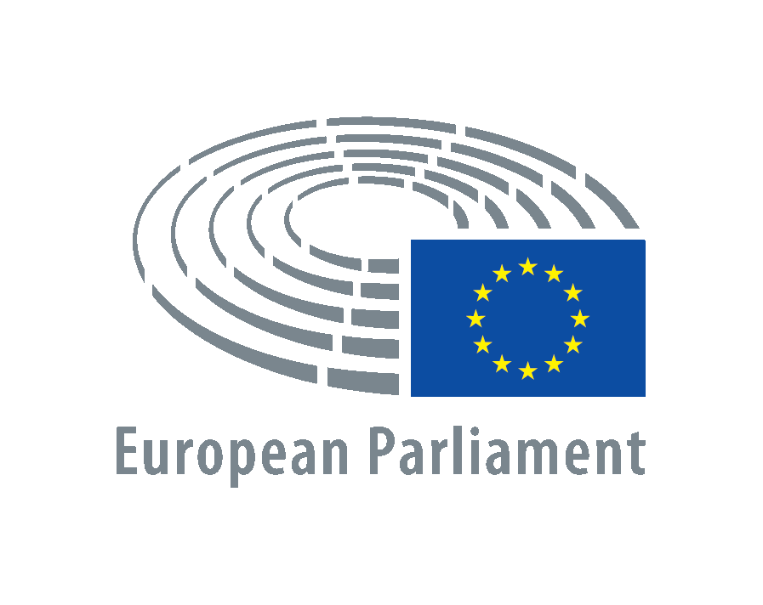

November 13th, 2020

Dear Mr Borrell,

We, the undersigned members of the Western Sahara Intergroup in the European Parliament, we want to express our concern about the breakdown of the ceasefire perpetrated this morning by the Moroccan army in the area of Guerguerat.

The Guerguerat, in the south-west corner of Western Sahara by the border with Mauritania, is an area under the control of MINURSO, included within the peace agreements signed in 1991 and in the military agreement number 1.

Despite this, some years ago Morocco started building a tarmac road - unilaterally and illegally - with the lucrative aim of trading products through this new pass with Mauritania, products that often come from the natural resources plundered from the Western Sahara. This is illegal under international law, yet this illegal passage has become fundamental to Morocco's trade with sub-Saharan Africa.

Faced with this situation, dozens of Saharawis have been peacefully protesting in the Guerguerat area since 21 October to protest against this illegal passage and against the violation of the peace agreement and the constant violation of human rights suffered by the Saharawi people by the Moroccan occupation forces. Morocco responded sending Army troops, Gendarmerie and other security forces to the area.

We recall that this is not the first time that the Guerguerat area has been the centre of intense tensions. It already happened in 2017 with the international community stood idly by.

Today, 13 November, Morocco has broken the ceasefire signed over thirty years ago under the auspices of the UN by sending military forces against the Sahrawi civilians, and the Sahrawi army has responded to defend its population.

As members of the Western Sahara intergroup we call on you to condemn these unilateral actions of Morocco and work for a peaceful solution in line with international law and the respect for Sahrawi sovreignty. We recall that the lucrative trade agreements the EU has with Morocco are conditioned to human rights, and this is the last example of their complete disregard in the Western Sahara by Moroccan occupation authorities. This impunity must end now.

We also ask you to use the EU’s presence and influence in the competent international for a to guarantee that the MINURSO accomplishes its mandate of organizing a referendum in Western Sahara. During these years there has been no progress towards holding this promised referendum. We also believe that it is unacceptable and a sign of Morocco's impunity the fact that the MINURSO has never been given the competence to monitor human rights in the region.

The future of the peace agreement is today more at stake than ever and we believe that the international community can no longer turn its back on this conflict, which has been abandoned for 45 years.

Best regards,

PINEDA Manu
BARRENA Pernando
REGO Sira
GUTELAND Jytte
GROSELJ Klemen
INCIR Evin
GUERREIRO Francisco
MATIAS Marisa
GUSMAO José
VILLANUEVA Idoia
BJORK Malin

